NOTTINGHAMSHIRE POLICE

JOB DESCRIPTION

Job title: Communications and Engagement Officer (P3)

Department/ Location: Corporate Communication Department, HQ

Responsible to: Senior Media and External Relations Officer and Senior Campaigns and Marketing Officer (joint)

Date: September 2021

Library no.; HMIC Classification:

JOB PURPOSE

At the direction of the Head of Corporate Communication, and via supervision from both the Senior Media External Relations Officer and the Senior Campaigns and Marketing Officer, take an active role in the delivery of communication and engagement activity to meet the strategic aims of Nottinghamshire Police, through the robust use of communications channels, both internally and externally.

Develop, deliver and evaluate communication and engagement strategies and products for both internal and external audiences, ensuring the force’s strategic operational priorities and key messages are clear and embedded in the delivery of service.

PRINCIPAL ACCOUNTABILITIES

1 | At the direction of the Head of Corporate Communication, and via supervision from both the Senior Media External Relations Officer and the Senior Campaigns and Marketing Officer, take an active role in the creation and delivery of communication and engagement activity to meet the strategic aims of Nottinghamshire Police, through the robust use of communications channels, both internally and externally.
2. | Develop, deliver and evaluate communication and engagement strategies, and products to identify opportunities to improve staff engagement. Ensure the force’s strategic operational priorities, values and key messages are clear and embedded in the delivery of service.
3. | Design, implement and evaluate research-led tactical plans, products and portfolios, both internally and externally, at a corporate and local level, to prevent and detect crime, enhance performance, engage communities and manage emerging trends and critical incidents effectively, using customer insight / research to understand specific audiences and their drivers.
4. | Receive and manage media enquiries (international, national, regional and local), making decisions about the appropriate response to be given in order to support the operational needs of the force and enhance public confidence.
5. | Ensure the corporate brand is consistently applied to all communication channels to reflect and support key messages, and maximise their potential through effective channel management.
6. | Act as Bronze and, at times, deputising as Silver Communications Officer in the event of a major / critical incident. Develop and implement approaches to manage the communication and engagement relating to such incidents, in liaison with the Senior Investigating Officer (SIO), senior departmental colleagues and, when appropriate, other agencies involved in the incident, at times acting as force spokesperson in media interviews.
7. | Using experience, demographic / customer insight and research, provide advice to officers and staff, at all levels, about how best to communicate and engage with internal and external audiences, through effective targeted channel management and monitoring of digital platforms, and providing feedback.
8. | Arrange and facilitate corporate events, using associated communication and engagement products, helping officers and staff to communicate and engage with communities and assist in the delivery of the force’s reward and recognition scheme through internal ceremonies, to support the ambition of the force being an employer of choice.
9. | Develop, maintain and enhance relationships with key stakeholders, including national, regional and local media organisations, to maximise positive and supportive coverage for the delivery of policing services in Nottinghamshire.
10. | Assist both the Senior Media External Relations Officer and the Senior Campaigns and Marketing Officer with the delivery of communication and media training for all key force personnel and provide strategic and tactical advice and adhoc training, when required, about internal communication and engagement, campaigns, news management and media issues to staff.
11. | Participate in the out-of-hours on call rota system.
12. | Engage in direct interaction with officers and staff, and the public online through effective channel management and monitoring of digital platforms, internally and externally, and upload content when required.
13. | Participate in the Force PDR process and take responsibility for identifying your own professional and career development needs.

DIMENSIONS

Financial: N/A

Staff N/A

Sphere of activity: The post holder will be responsible for the delivery of a range corporate communication and engagement activities and products, across internal and external platforms.

Management vetting is required given the sensitive nature of some of the material and information to which they will be exposed to in order to execute their duties.

The post holder will be required to undertake responsibility on a rota basis for providing an out of hours ‘on call’ service to the force in the event of major issues and critical incidents, attending the scene of major incidents, acting as the focal point for media enquiries and developing strategic and tactical communications activity in order to support the needs of investigations and enhance public confidence.

ORGANISATIONAL/DEPARTMENTAL CHART

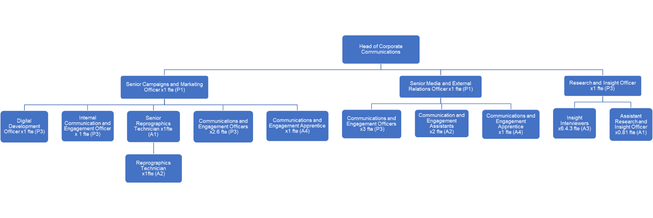

ACCOUNTABILITY

Prepared by: Emma Hollingworth, Head of Corporate Communication Date: September 2021

NOTTINGHAMSHIRE POLICE

PERSON SPECIFICATION

Job Title: Communications and Engagement Officer

Department/Location: Corporate Communication Department, HQ

Date: September 2021
CRITERIA | METHOD OF ASSESSMENT
KNOWLEDGE AND EXPERIENCE  Demonstrable experience in the delivery of communications and / or engagement activity (e.g. journalism / marketing) for a large organisation.  Extensive experience of written communications activity, writing articles, features and copy for publication.  A proven understanding and experience in the use of a range of traditional communication and engagement mechanisms, internal communication and social and digital media platforms, including the production of audio and video to target different audiences.  Proven experience in the successful planning and delivery of communication and / or engagement strategies, targeting several different audiences.  A desirable understanding or experience of communications activity within the police service or another aspect of public sector life.  Sound knowledge of legislation which impacts upon media coverage and criminal justice procedures and sound knowledge of legislation which impacts upon web-based communications.  Experience of operating within a partnership / stakeholder arena and political astuteness in order to deliver communication projects and packages by engaging with stakeholders. | Application form / interview  Application form  Application form / interview  Application form / interview  Application form / interview  Application form / interview  Application form / interview
SKILLS AND ABILITIES  Strong written, oral, presentational communication skills.  Ability to understand, précis and convert complicated material from a range of sources into bright, intelligible and concise written and visual products for a range of different audiences and for a range of different traditional and social and digital media platforms.  An understanding of how to record audio and visual and upload to digital media platforms.  Ability to produce creative and imaginative communication and engagement products for diverse audiences, across multiple platforms.  Demonstrable ability to work equally on own initiative, with proven creativity and innovation, and as part of a team.  Ability to prioritise and manage workload efficiently and effectively and remain calm and positive, often in challenging and highly stressful circumstances. | Application form / interview  Application form / interview  Application form/interview  Interview  Application form / interview  Application form / interview
EDUCATION / QUALIFICATIONS  Hold the National Council for the Training of Journalists / National Certificate Examination or similar qualification (for example, Chartered Institute of Marketing or Chartered Institute of Public Relations) or have relevant or equivalent professional experience.  Demonstrable computer skills, a sound knowledge of video and audio editing software, social media usage and various other industry packages including SharePoint and Adobe Creative Suite, particularly InDesign, Photoshop and Illustrator on a Mac and / or PC. | Application form  Application form / interview
OTHER  Must be aware of and / or have the ability to develop a personal commitment to and awareness of equal opportunities, championing diversity and the force’s PROUD values  Must be able to routinely travel to locations across the county and occasionally outside the county.  Flexible approach to work and prepared to work outside normal working hours when required to meet deadlines and demands, and be prepared to support the force’s wider communication needs in the event of critical and major incidents, being required to work unsociable hours.  Willing to participate in the out of hours on call rota. | Interview  Application form  Interview  Application form

ACCOUNTABILITY

Prepared by: Emma Hollingworth, Head of Corporate Communication

Signature: ……………………………………………… Date: September 2021

